### Dr. AMBEDKAR INSTITUTE OF TECHNOLOGY

Near Jnana Bharathi Campus, Bengalooru-560 056.

(An Autonomous Institution, Aided by Government of Karnataka)



##### **Project Report on**

**“MILK DAIRY MANAGEMENT SYSTEM”**

**Submitted By**

**VARSHA K M VARUN HEGDE**

**1DA16CS155 1DA16CS156**

**Under the guidance**

**Of**

**Mrs. Rashmi**

**Asso. Prof., Dept. of CSE Assoc. Prof., Dept. of CSE**

**Dr. AIT Dr. AIT**

**Department of Computer Science & Engineering**

**2018-19**

Dr. AMBEDKAR INSTITUTE OF TECHNOLOGY

Near Jnana Bharathi Campus, Bengalooru-560 056.

(An Autonomous Institution, Aided by Government of Karnataka)



**CERTIFICATE**

This is to certify that the project entitled “**MILK DAIRY MANAGEMENT SYSTEM**” submitted in the partial fulfilment of the requirement of the 5th semester mini project curriculum during the year 2018-19 is a result of bona fide work carried out by

**VARSHA K M VARUN HEGDE**

**1DA16CS155 1DA16CS156**

Signature of the guide:

____________________

**Mrs. Rashmi**

**Asst. Prof., Dept. of CSE Asst. Prof., Dept. of CSE**

**Dr. AIT Dr. AIT**

1. Internal Examiner _____________

2. External Examiner _____________

**ACKNOWLEDGEMENT**

The satisfaction that accompanies to this project would be incomplete without the mention of the people who made it possible, without whose constant guidance and encouragement would have made our efforts go in vain.

We consider ourselves privileged to express our gratitude and respect towards all those who guided us through the project, “**MILK DAIRY MANAGEMENT SYSTEM”**.

We would like to express our gratitude to **Dr. NANJUNDASWAMY, Principal, Dr. AIT,** for providing us the congenial environment to work in.

We would like to express our profuse gratitude to **Dr. SIDDARAJU, HOD, Dept. of Computer Science & Engineering, Dr. AIT,** for giving us the support, encouragement and providing us the required lab facilities that was necessary for the completion of this project.

As a token of gratitude, we would like to acknowledge our sincere gratefulness to the internal guide **Mrs.RASHMI , Asst Professor, Dept. of CSE, Dr.AIT & , Asst Professor, Dept.of CSE,Dr AIT** for his/ her unlimited support and encouragement provided throughout the process.

We also express our gratitude and sincere thanks to all the teaching and non-teaching staff of **Computer Science & Engineering Department.**

Finally, yet importantly, we would like to express our heartfelt thanks to our beloved **Parents** for their blessings and our **Friends** for their help and wishes for the successful completion of this project report.

**VARSHA K M**

**VARUN HEGDE**

**ABSTRACT**

The milk dairy management system is inherently based on database systems. The data is structurally stored. Second, it has a solid theoretical foundation, from framework and data model to query language. Last, it can retrieve detailed or required information about the dairy it is being implemented on, at any point of time and any instance of space. By understanding how huge the milk industry is and the perils related to the distribution and storing/retrieval of data, we hope to give a better understanding as to how the managers may work together to address shortfalls with consideration for local, national and international priorities. For the professional community, the management system we have developed benefits all walks of people involved in the running of a full-fledged functioning dairy at local level, however vast or complicated the system might be by providing strategies for dealing with the data and changing demands, needs and requirements.

Milk dairy management system undertaken as a project is based on relevant, easy to use, wide spread plus user friendly technologies. The aim of this project is to develop software for a milk dairy. It has been developed to carry out the process easily and quickly, which is not possible with the manual system. This project is developed with Oracle 10g and hence it provides the complete solution for the current management system.

**CONTENTS**

1. Introduction

2. System requirement specification

3. Design of project

3.1 Introduction

3.2 ER diagram

3.3 Schema diagram

4. Implementation

5.Coding

6.Snapshots

7.Query

8.System testing and results

9. Conclusion and Future enhancements

10. Reference

1. **INTRODUCTION**

The milk dairy management system allows us to store the complete information related to the functioning of the dairy on a daily basis. It cumulatively stores data and the same can be accessed, from the time it is in use. Our management system saves the details of the providers, distributors and employees involved. The input date along with the quantity of milk and the area it is being delivered from are collectively stored. Also, the packaging specifications are maintained. The system gives us a detailed analysis of the amount of milk received, packed, distributed and the profit made which can be summed as a whole as the sales stats. The same system can be used at all the branches of the dairy to fill in information. The dairy center or main branch can estimate the total sales by taking into consideration all of the areas, in the form of canned transactions. Thereby, it can be used to access any day’s/month’s or year’s stats.

**2. SYSTEM REQUIREMENTS SPECIFICATION**

**Introduction**

The purpose of this document is to describe all the requirements for the MILK DAIRY MANAGEMENT SYSTEM

* In this Database we can add ‘Provider’ details, ‘Distributor’ details, ‘Employee’ details and the total collected plus distributed milk.
* The details related to the Provider can be searched with the help of PID.
* The details related to the Distributor can be searched with the help of DID.
* The details related to the Employee can be searched with the help of EID.
* The number of packets prepared for a particular day is stored.
* The number of packets sold on a day is stored.
* The total investment on the milk including the packing is dealt with.
* The outgoing packets that are sold are kept account of.
* The total sales made for the day is summed.
* Lastly, the profit made for the day is also calculated and stored by subtracting the incoming and outgoing milk.

**General Description**

**Functions**

The system functions can be described as follows:

1. Add provider: The milk dairy management system allows front desk staff to add new providers to the system. The provider ID is maintained such that we can identify the district, taluk, gram and area on seeing the number.
2. Add distributor: The milk dairy management system allows front desk staff to add new distributors to the system. We can identify the district and taluk of the distributor using the distributor ID.
3. Add employee: The milk dairy management system allows a front desk member to add new employees to the system.
4. Milk input: The system maintains details about total incoming milk along with the area it is coming from, cost and total payment made for a particular day.
5. Milk details: The cost of milk per liter on that particular day accounting to the changing standards of the country is maintained along with the total milk received and sold.
6. Packaging: The total number of packets manufactured as well as the cost per packet and the total cost of the milk packet after adding the cost of the packet for the day is maintained.
7. Transaction details: This milk dairy management provides details about the total incoming and outgoing milk and so does it provide the amount of profit made for that specific day.
8. Report**:** The management system can generate reports based on the sales stats of each day after proper processing.
9. Delete an ID: The system allows deletion of the details of a provider, distributor or employee on their unavailability.

**User characteristics**

The system will be used in the dairy. The database management admin and staff users are the main users. Given the condition, not all the users are computer literate. Some users have to be trained for using the computer system. The system is also designed to be user friendly.

* + Database management staffs: The providers, distributors who have an account provide and distribute the milk and the data is entered accordingly.
* Database admin: There shall be an admin who is heads and monitors the database including access protection. He is in charge of the report generation and sales stats.

**Assumptions and dependencies**

* It is assumed that compatible computers will be available before the system is installed and tested.
* It is assumed that the dairy will have enough trained staff to take care of the system.

**Specific requirements**

This application has mainly interface part and the data storage part. The interface part concentrated on the use of interface part that has to be developed in order to facilitate easy understanding of the functions. The data store part is more complex but very important part. Data will be stored in the disk.

**TECHNICAL FEASIBILITY**

The technical feasibility is the most difficult area to encounter at this stage. It is essential that the process of analysis and definition be conducted in parallel with and assessment of technical feasibility.

It concentrates on the existing computer system and to what extent the proposed system can be supported. Though information in manuals in enormous, it can be handled easily by the Visual Basic 6.0 and SQL Server 2005. Information in the table form is easy to access and manage, computer department is already equipped with suitable system and it can be utilized for the development of the system. Hence it is technically feasible for developing a new computerized system.

**OPERATIONAL FEASIBILITY**

The proposed system offers greater levels of user friendliness combined with greater processing speed. Therefore, automation reduces number of staffs required. Since the processing speed is very high compared to that of manual process, the management can take timely action depending on the information obtained. Hence the project is operationally feasible. The system study and problem formulation phases play an important role in the system development life cycle.

**User interface**

The system uses the CRT monitor for displaying the output and keyboard and mouse for giving the inputs.

**Design Constraints**

* Database: The system shall use the Oracle10g Database, which is open source and free.
* Operating System: The Development environment shall be Windows 7 & above versions.
* Web-Based: The system shall be a Web-based application.

**3. Design of the Project**

**3.1 Introduction**

* The topic provides idea regarding general structure of database design keeping system constrains and functionality, in view. The design means to plan or sketch out the form and method of a solution. The design represents the major characteristic of the final system and determines the upper bound in quality for the system.
* System design emphasizes on two aspects of a system:

1. Dividing the system into components.
2. Defining the interrelationship between the components.

Logical Design: This step describes the features, the inputs, the outputs, tables, databases and procedures to meet the project requirements

Physical Design: Programs are written to accept user input, process the data, produces output or reports and store data in database.

We divide the project design into four fragments

1. Output Design: For many end-users, output is the main reason for developing the system. Output design involves:

Determining what information is present.

Decide whether to display or print the information.

Presentation in an acceptable format.

1. Input Design: Input design specifies how data are accepted for processing.

This involves:

What data to input?

How data should be arranged or coded?

1. Control Design: Controls provide ways to:

Ensure that only authorized users access the system.

Guarantee that transactions are acceptable.

Determine whether any necessary data have been omitted.

1. Database Design: The database system must provide for the safety of information stored in the database despite system crashes or attempt unauthorized access.

**3.2 ER-Diagram**

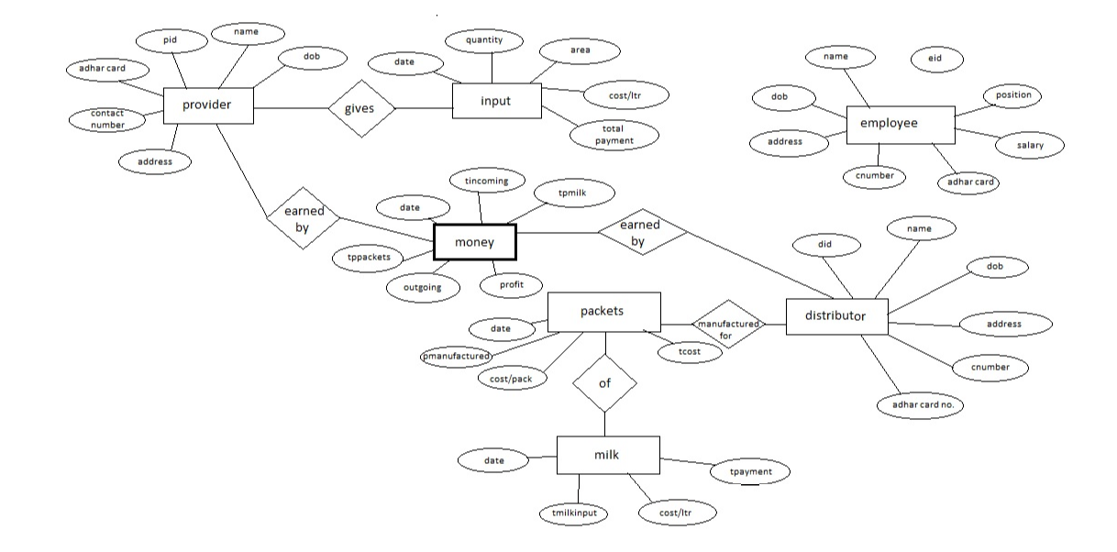**3.3 Schema Diagram**

**PROVIDER:**

|  |  |  |  |  |  |
| --- | --- | --- | --- | --- | --- |
| **PID** | **Name** | **DOB** | **Address** | **Contact_no** | **Aadhar_card** |

**DISTRIBUTOR:**

|  |  |  |  |  |  |
| --- | --- | --- | --- | --- | --- |
| **DID** | **Name** | **DOB** | **Address** | **Contact_no** | **Aadhar_card** |

**EMPLOYEE:**

|  |  |  |  |  |  |  |  |
| --- | --- | --- | --- | --- | --- | --- | --- |
| **EID** | **Name** | **DOB** | **Address** | **Contact_no** | **Aadhar_card** | **Position** | **Salary** |

**INPUT:**

|  |  |  |  |  |  |
| --- | --- | --- | --- | --- | --- |
| **Date** | **Sl_no** | **Quantity** | **Area** | **Cost_per_ltr_of_milk** | **Total_payment** |

**MILK:**

|  |  |  |  |  |
| --- | --- | --- | --- | --- |
| **Date** | **Sl_no** | **Total_milk_input** | **Cost_per_ltr_of_milk** | **Total_payment** |

**PACKET:**

|  |  |  |  |  |
| --- | --- | --- | --- | --- |
| **Date** | **Sl_no** | **Packets_manufactured** | **Cost_per_pack** | **Total_cost** |

**MONEY:**

|  |  |  |  |  |  |  |  |  |
| --- | --- | --- | --- | --- | --- | --- | --- | --- |
| **Date** | **Sl_no** | **Packets processed** | **Cost_per_ packet** | **Total incoming** | **Total_ payment for_ packets** | **Total_ payment for_milk** | **Total_ outgoing** | **Profit** |

1. **Implementation**

As all the software program is implemented by dividing into different modules to know the details of whole processing and they will interact with each other to maintain the data and information module structure. It is designed with the concept of considering the case of maintaining the logic for modification and maintenance. Since the software program must interact with database. *Oracle as Back end tool* for data base architecture is used.

The Back End consists of

-Tables to store your data.

-Queries to find and retrieve just the data you want

-Forms to view, add and update data in tables.

-Reports to analyze or print data in a specific layout.

-Data access pages to view, update, or analyze the database’s data

**5.Coding**

**CREATE TABLES:**

create table provider

(

PID number(10) primary key,

Name varchar(20),

DOB varchar(15),

Address varchar(100),

Contact_no number(10),

Aadhar_card varchar(15)

);

create table distributor

(

DID number(5) primary key,

Name varchar(20),

DOB varchar(15),

Address varchar(100),

Contact_no number(10),

Aadhar_card varchar(15)

);

create table employee

(

EID number(5) primary key,

Name varchar(20),

DOB varchar(15),

Address varchar(100),

Contact_no number(10),

Aadhar_card varchar(15),

Position varchar(20),

Salary real

);

create table input

(

Sl_no int,

Dates varchar(15),

Quantity real,

Area varchar(20),

Cost_per_ltr_of_milk real,

Total_payment real,

primary key (Sl_no),

foreign key (Dates) references milk (Dates)

);

create table milk

(

Dates varchar(15),

Total_milk_input real,

Cost_per_ltr_of_milk real,

Total_payment real,

primary key (Dates)

);

create table packet

(

Sl_no int,

Dates varchar(15),

Packets_manufactured real,

Cost_per_pack real,

Total_cost real,

primary key (Total_cost),

foreign key (Dates) references milk (Dates)

);

create table money

(

Sl_no int,

Dates varchar(15),

Packets_processed real,

Cost_per_packet real,

Total_incoming real,

Total_payment_for_milk real,

Total_payment_for_packets real,

Total_outgoing real,

Profit real,

primary key (Sl_no),

foreign key (Dates) references milk (Dates),

foreign key (Total_payment_for_packets) references packet (Total_cost)

);

**INSERT VALUES:**

insert into provider values('110512032','Akash Naik','01-03-1982','Shreenivasa,Bilgi,Siddhapura,UK','9568423785','4526 4585 4559');

insert into provider values('110512012','Abhishek Bhat','23-04-1983','Shreenidhi,Bilgi,Siddhapura,UK','9362514785','6223 2456 4458');

insert into provider values('110613003','Adarsh Hegde','15-07-1985','Anugraha,Janmane,Sirsi,UK','9845236524','9325 4298 4528');

insert into provider values('110613004','Darshan Gouda','07-05-1980','Shriprasanna,Janmane,Sirsi,UK','9562314785','1475 2563 1258');

insert into provider values('110614032','Akshay N A','03-02-1978','Abhibhava,Heggarni,Sirsi,UK','9547812364','1856 4569 1258');

insert into provider values('110614033','Shravan K R','17-10-1980','Sourabha,Heggarni,Sirsi,UK','9654238512','2365 1254 1247');

insert into provider values('110801001','Varsha K M','05-03-1985','Lakshminilaya,Kirwatti,Yellapura,UK','9535146253','4256 1478 2569');

insert into provider values('110801002','Varun Hegde','03-03-1985','Vaikuntta,Kirwatti,Yellapura,UK','9482055744','8592 0544 3886');

insert into distributor values('1105','R N Shetti','12-12-1982','Ashrita,Halgere,Siddhapura,UK','9326541286','4556 1252 4486');

insert into distributor values('1106','P N Shetty','15-11-1980','Benaka,Devikere,Sirsi,UK','9596849123','6652 4528 9632');

insert into distributor values('1108','Raju Naik','19-08-1982','Prarthana,Nadig galli,Yellapura,UK','9125475852','6542 1235 8596');

insert into distributor values('1202','Suresh Bant','25-04-1979','Gajendra,Kajubag,Karwar,UK','9933959684','8852 6592 1235');

insert into distributor values('1203','Imran Khan','08-09-1981','Feroz Mahal,Muslim Galli,Bhatkal,UK','9362561423','7589 6582 1256');

insert into employee values('121','Siddharth Venekar','12-06-1987','Aaradhana,CP Bazar,Sirsi,UK','9632587412','4556 4253 1256','Manager','100000');

insert into employee values('122','Sohan Kumar','22-04-1985','Kalpavraksha,Hanumanti,Sirsi,UK','9874563210','9652 5623 1258','Accountant','75000');

insert into employee values('123','Prashant Advani','09-01-1990','Dhanvantari,Kolgibees,Sirsi,UK','9125638740','1456 8965 2589','Asst.Manager','80000');

insert into employee values('124','Ganesh Prabhu','19-08-1989','Samanvitha,KHB Colony,Sirsi,UK','9658214956','7458 6522 1221','Driver','25000');

insert into employee values('125','Sandhya S','29-12-1986','Sameeksha,Harugar,Sirsi,UK','9896596210','8856 3326 1244','Secretary','30000');

insert into input values('1','01-10-2018','500','Sirsi','38','19000');

insert into input values('2','01-10-2018','420','Siddhapura','38','15960');

insert into input values('3','01-10-2018','470','Yellapura','38','17860');

insert into input values('4','02-10-2018','550','Sirsi','38','20900');

insert into input values('5','02-10-2018','470','Siddhapura','38','17860');

insert into input values('6','02-10-2018','430','Yellapura','38','16340');

insert into input values('7','03-10-2018','530','Sirsi','38','20140');

insert into input values('8','03-10-2018','485','Siddhapura','38','18430');

insert into input values('9','03-10-2018','495','Yellapura','38','18810');

insert into input values('10','04-10-2018','520','Sirsi','38','19760');

insert into input values('11','04-10-2018','465','Siddhapura','38','17670');

insert into input values('12','04-10-2018','432','Yellapura','38','16416');

insert into input values('13','05-10-2018','512','Sirsi','38','19456');

insert into input values('14','05-10-2018','486','Siddhapura','38','18468');

insert into input values('15','05-10-2018','485','Yellapura','38','18430');

insert into input values('16','06-10-2018','532','Sirsi','39','20748');

insert into input values('17','06-10-2018','456','Siddhapura','39','17784');

insert into input values('18','06-10-2018','425','Yellapura','39','16575');

insert into input values('19','07-10-2018','532','Sirsi','39','20748');

insert into input values('20','07-10-2018','426','Siddhapura','39','16614');

insert into input values('21','07-10-2018','478','Yellapura','39','18642');

insert into input values('22','08-10-2018','512','Sirsi','39','19968');

insert into input values('23','08-10-2018','478','Siddhapura','39','18642');

insert into input values('24','08-10-2018','498','Yellapura','39','19422');

insert into input values('25','09-10-2018','536','Sirsi','39','20904');

insert into input values('26','09-10-2018','456','Siddhapura','39','17784');

insert into input values('27','09-10-2018','489','Yellapura','39','19071');

insert into input values('28','10-10-2018','510','Sirsi','39','19890');

insert into input values('29','10-10-2018','495','Siddhapura','39','19305');

insert into input values('30','10-10-2018','473','Yellapura','39','18447');

insert into milk values('01-10-2018','1390','38','52820');

insert into milk values('02-10-2018','1450','38','55100');

insert into milk values('03-10-2018','1510','38','57380');

insert into milk values('04-10-2018','1417','38','53846');

insert into milk values('05-10-2018','1483','38','56354');

insert into milk values('06-10-2018','1413','39','55107');

insert into milk values('07-10-2018','1436','39','56004');

insert into milk values('08-10-2018','1488','39','58032');

insert into milk values('09-10-2018','1481','39','57759');

insert into milk values('10-10-2018','1478','39','57642');

insert into packet values('1','01-10-2018','2780','3','8340');

insert into packet values('2','02-10-2018','2900','3','8700');

insert into packet values('3','03-10-2018','3020','3','9060');

insert into packet values('4','04-10-2018','2834','3','8502');

insert into packet values('5','05-10-2018','2966','3','8898');

insert into packet values('6','06-10-2018','2826','4','11304');

insert into packet values('7','07-10-2018','2872','4','11488');

insert into packet values('8','08-10-2018','2976','4','11904');

insert into packet values('9','09-10-2018','2962','4','11848');

insert into packet values('10','10-10-2018','2956','4','11824');

insert into money values('1','01-10-2018','2780','24','66720','52820','8340','61160','5560');

insert into money values('2','02-10-2018','2900','24','69600','55100','8700','63800','5800');

insert into money values('3','03-10-2018','3020','24','72480','57380','9060','66440','6040');

insert into money values('4','04-10-2018','2834','24','68016','53846','8502','62348','5668');

insert into money values('5','05-10-2018','2966','24','71184','56354','8898','65252','5932');

insert into money values('6','06-10-2018','2826','26','73476','55107','11304','66411','7065');

insert into money values('7','07-10-2018','2872','26','74672','56004','11488','67492','7180');

insert into money values('8','08-10-2018','2976','26','77376','58032','11904','69936','7440');

insert into money values('9','09-10-2018','2962','26','77012','57759','11848','69607','7405');

insert into money values('10','10-10-2018','2956','26','76856','57642','11824','69466','7390');

**6. SNAPSHOTS**

**select * from provider;**

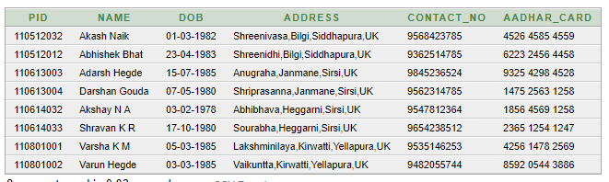

**select * from distributor;**

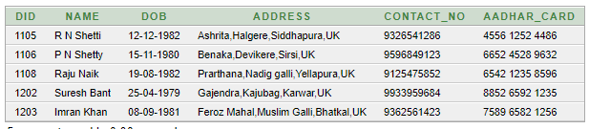

**select * from employee;**

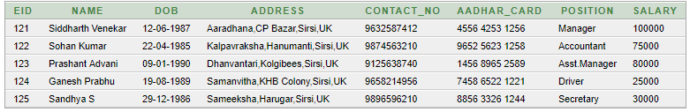

**select * from input;**

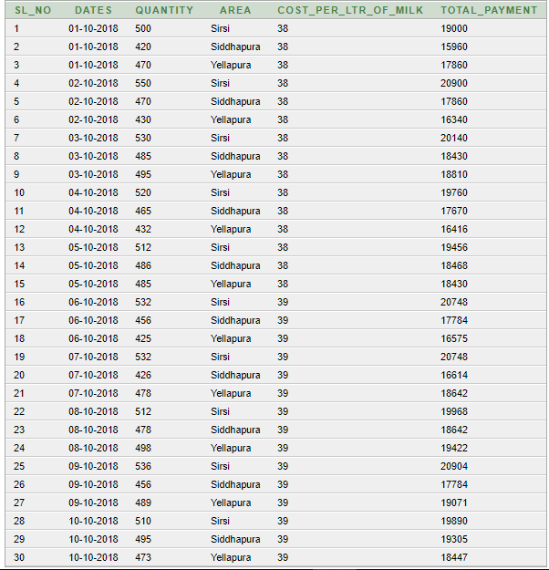

**select * from milk;**

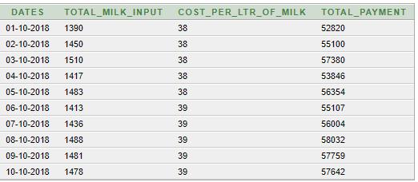

**select * from packet;**

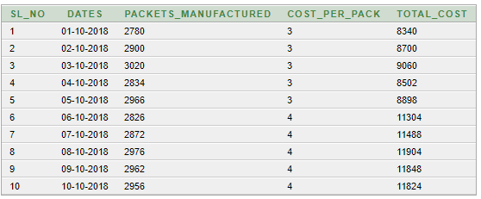

**select * from money;**

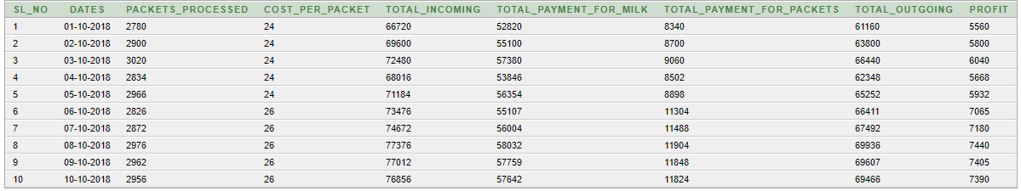

**7. QUERY**

**1)Retrieve the names and salaries of the employees of the position 'manager' and salary greater than '79000'.**

**=>select Name, Salary**

**from employee**

**where Position like '%Manager' and**

**Salary>79000;**

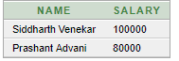

**2)Print the profits earned on days when the cost per ltr of milk given for the provider was Rs.38.**

**=>select m.Dates, m.Profit**

**from money m,milk l**

**where m.Dates=l.Dates and**

**l.Cost_per_ltr_of_milk='38';**

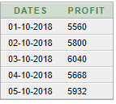

**3)Print the total profit earned on days when cost per ltr of milk was 38 and provided form sirsi.**

**=>select sum(Quantity)**

**from input**

**where Area='Sirsi' and**

**Cost_per_ltr_of_milk='38'**

**group by (Area);**



**4)Retrive the data for dates,packets manufactured & total cost when the incoming amount is less than 70000.**

**=>select Packets_manufactured, Total_cost, Dates**

**from packet**

**where Dates in (select Dates**

**from money**

**where Total_incoming<70000);**

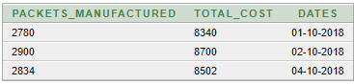

**5)Print quantity and area when profit earned is above 6000 and below 7000**

**=>select Dates, Quantity, Area**

**from input**

**where Dates in (select Dates**

**from milk**

**where Dates in (select Dates**

**from money**

**where Profit between 6000 and 7000));**

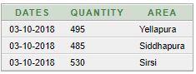

**8.System Testing and Results**

During system testing, the system is used experimentally to ensure that the software does not fail, specific test data are input for processing and results examined. It is desirable to discover any surprises before the organization implements the system & depends on it.

* **Testing Objectives**

i) Testing is a process of executing a program with the intent of finding an error.

ii) A good test case is one that has a high probability of finding an undiscovered error.

iii) A successful test is one that uncovers an undiscovered error.

* **Testing Principles**

· All tests should be traceable to customer’s requirements.

· Test should be planned long before the testing begins.

· Testing should begin “in the small” & progress towards “in the large”.

· Exhaustive Testing is not possible.

· To be most effective, an independent third party should conduct testing.

**Application**

* The database system provides the searching facilities to the users to view the sales and personal details.
* Manages the information of providers, distributors and employees.
* Shows the information and description of the daily sales in the form of views to the casual end users.
* To increase efficiency of managing a milk dairy.
* Manage the information of payment.
* Generation of suitable reports at the end of a day or month or year or as required.
* Allows querying for better analysis of the data.

**9. Conclusion and Future Enhancements**

The project **Milk dairy management system** is for computerizing the working in a milk dairy. The software takes care of all the requirements of a digital transaction details maintaining system and is capable to provide easy and effective storage of information related to overall transaction of a dairy. It generates the issue details of providers and distributors.

There is always a scope of betterment and the member system is not against this perception. At present the system satisfies most of the functions of the dairy management system. This project is especially designed for dairy management to take appropriate steps to improve the working standards and documentation through computerization.

• Generating of important reports on a daily, monthly or yearly basis or as required.

• Storing large amount of data for future point of view.

• Reducing manual efforts for maintaining the system.

• Reduction of the processing time**.**

• Assures security and validity. Provision for enhancement without disturbing the developed modules.

**10. References**

**Fundamentals of Database Systems** -Ramez Elmasri and Shamkant B Navathe

**Database Management Systems** - Raghu Ramakrishnan and Johannes Gehrke

[www.w3schools.com/php](http://www.w3schools.com/php)

[www.php.net/manual](http://www.php.net/manual)

[www.w3schools.com/html](http://www.w3schools.com/html)

[www.researchgate.net](http://www.researchgate.net)

[www.ecomputernotes.com](http://www.ecomputernotes.com)